**Demo using new versions of Luke (e.g. Luke 7.3.1)**New versions of Luke are downloaded from here: <https://github.com/DmitryKey/luke/releases/>  
**Note**: These newer versions of Luke use JavaFX for the GUI and require Java 1.8.6 or newer. Here’s the error you will see when using an older Java 1.8 version:  
Caused by: java.lang.NoSuchMethodError: javafx.scene.control.ChoiceBox.setOnAction(Ljavafx/event/EventHandler;)V

at org.apache.lucene.luke.app.controllers.fragments.search.SortController.initialize(SortController.java:83)  
  
**Here’s a Luke demo using Luke 7.3.1 with Solr 7.3.1**First we use DocSearcher to index the included “sampledocs” directory, then we run Luke and open the Lucene index directory of our sample Solr core, e.g. “C:\tmp\ds\DocSearcher\solr\solr-7.3.1\server\solr\core_sampledocs\data\index”.  
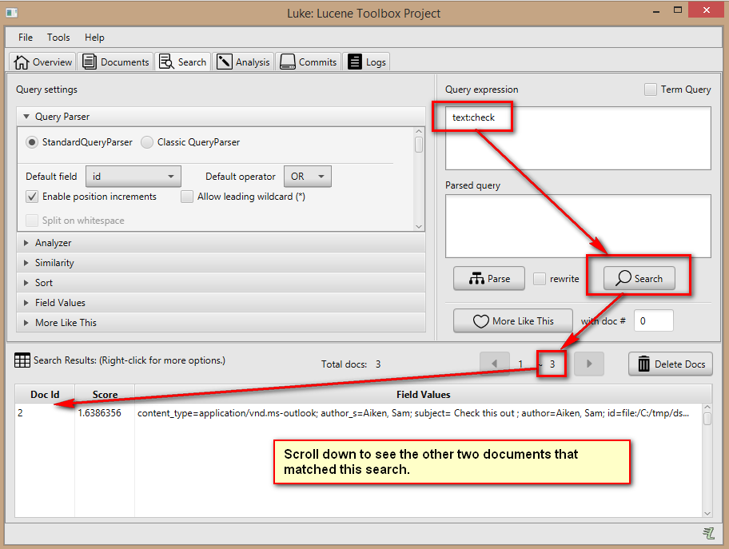  
  
**Note:** “Field Values” can be expanded to selectt the fields to display. If we reduce the number of displayed fields, we see all three documents in the output without needing to scroll down:  
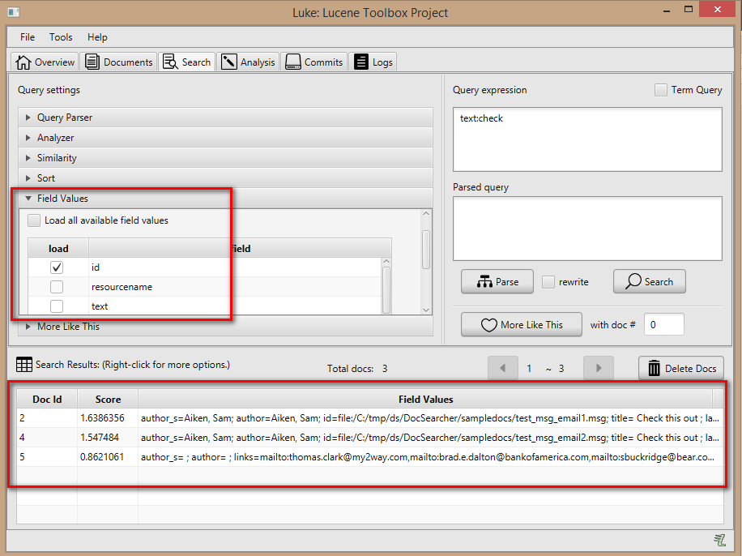  
  
  
*JeremyC 12-08-2018***END**